**NEW WEB ANALYSIS 6.0**

Navigation Bar

1. Blockchain page should navigate to Blockchain content /; refer <https://www.neurotags.com/fast-private-blockchain> , currently navigating to event page.
2. Video link navigation to video content : <http://vcqru.bhanguz.com/video.php> , currently navigating to this page.

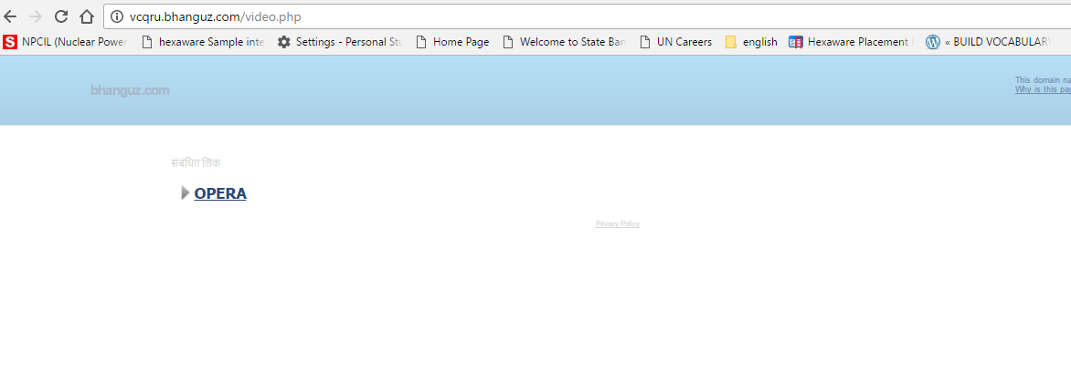

1. Login should navigate from internal pages also.
2. On 1st slider add Backed By Patent Pending Algorithm & AI
3. Site is running slow ; 2nd slider video is not loading
4. Get more details button color as per theme .
5. Sales safe buy safe icon
6. Images Icon of services need to be updated ; Unique images for Vcqru .. no google images.
7. About Us : Video section just above the login form.
8. Check code method and How do we benefit attractive ,with clear understanding animated flow
9. How do we benefit Icons Attractive with large.
10. Insert Track & Trace Solution and warranty management flow with content🡪 Under Benefits refer neurotags.com
11. Data in below animation : >>Purchase :100 Scan 95 Rescan :10

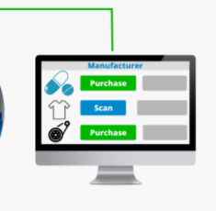

1. Image icon for this as per vcqru theme
   * 1. 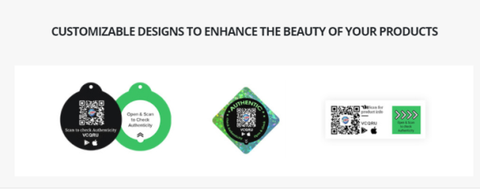
2. 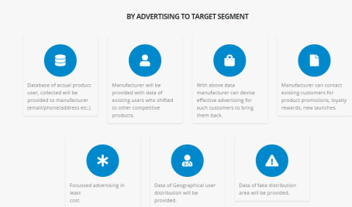‘By Advertising to target segment’ Font format and image icon clear and attractive

can refer:

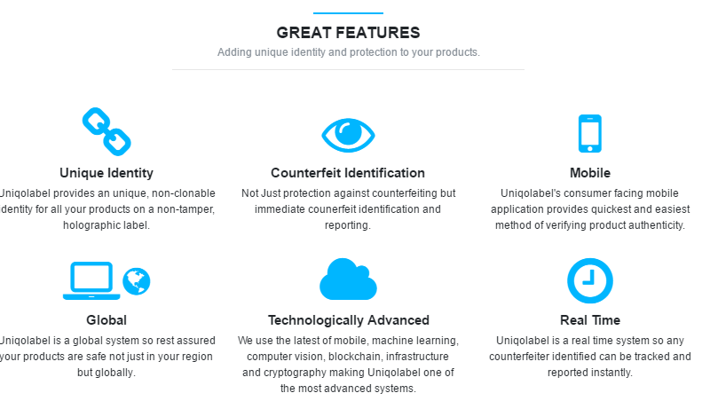

1. Here font format as per website and image icon need to be inserted.

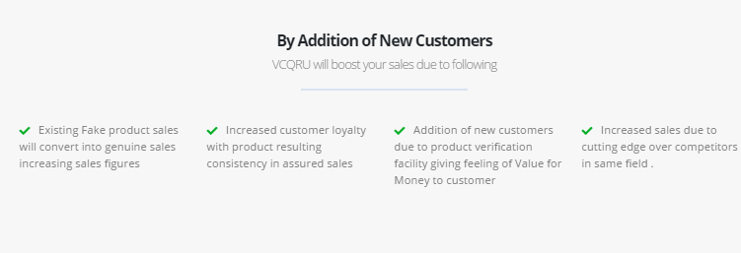

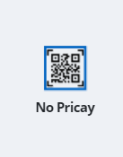

1. Spelling 🡪 Piracy
2. Drawbacks with images of drawback methods like : holograms , RFID tags as mentioned in content.

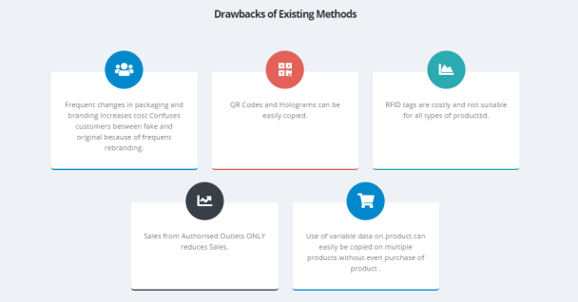

1. Text Uniqolabel🡪 Vcqru ; last image icon update of cross and right sign need to be updated.

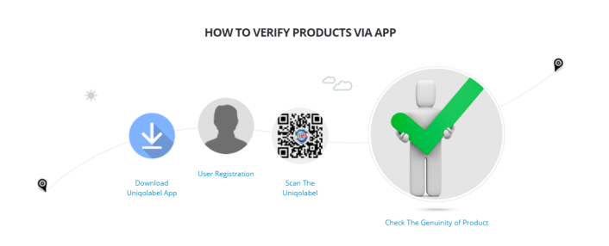

1. In footer ‘Get in touch ’ font format update , FAQ pdf file should open on terms & condition , Patent certificate page should open on Patent link ( shared files on mail)
   1. 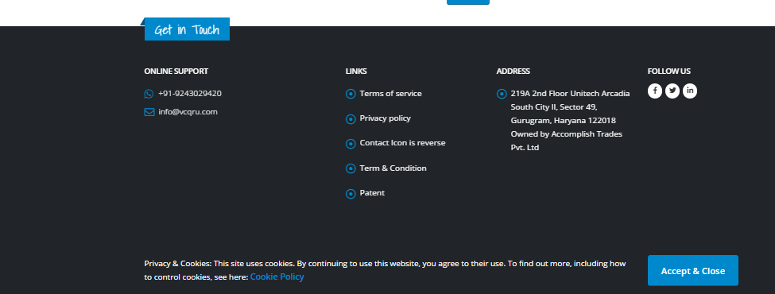
2. Links for social media content :
3. Navigation bar page should not load but swipe ,can refer wordpress one page website.
4. In logo TM need to be added . like 
5. Accept & close need to be closed once accepted [should appear only one time ]
6. Browse compatibility need to be checked .UI looks good in Microsoft edge not in Chromium 58 and Chrome 73 version . Should be compatible for all browsers.
7. Should be mobile compatible.